**Superstores Database**

**Q1.** select customer_name as 'customer Name', customer_segment as 'Customer Segment' from superstores.cust_dimen;

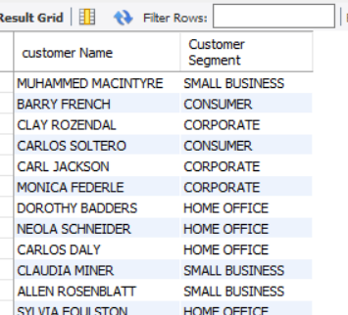

**Q2.** Select * from superstores.cust_dimen order by customer_Name desc;

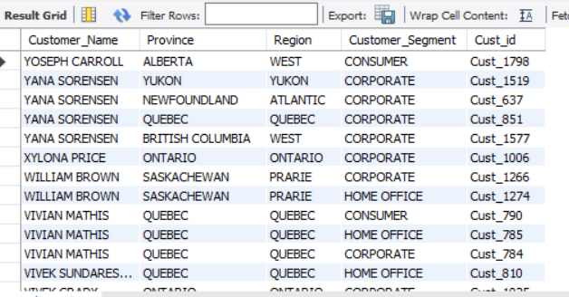

Q3. Select order_id, order_date, order_priority from superstores.orders_dimen where Order_Priority = 'high';

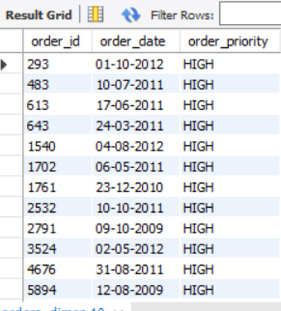

**Q4.** Select avg(sales) as avg_sales, sum(sales) as total_sales from superstores.market_fact;

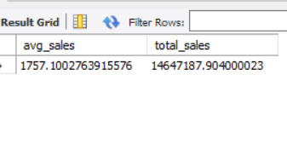

**Q5.** Select max(sales), min(sales) from superstores.market_fact;

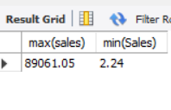

**Q6.** Select region, count(*)as no_of_customers from superstores.cust_dimen group by Region order by No_of_customers desc;

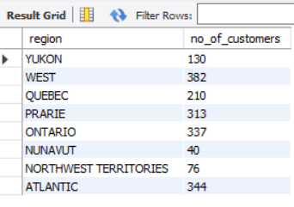

**Q7.** Select region, Count(*) as no_of_customers from superstores.cust_dimen group by Region order by No_of_customers desc limit 1;

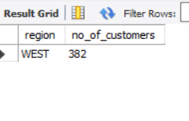

**Q8. select customer_name, count(market_fact.prod_id) from superstores.cust_dimen**

**join market_fact on market_fact.Cust_id = cust_dimen.Cust_id**

**join prod_dimen on prod_dimen.Prod_id = market_fact.Prod_id**

**where cust_dimen.Region = 'atlantic' and prod_dimen.Product_Sub_Category = 'tables'**

**group by cust_dimen.Customer_Name;**

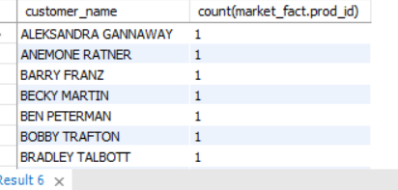

**Q9.** Select customer_name, customer_segment from superstores.cust_dimen

where 'Ontario' = Province and Customer_segment = 'small Business';

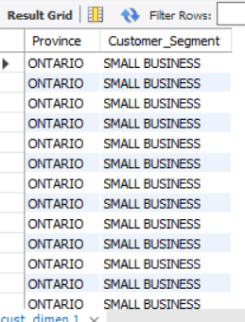

**Q10.** select market_fact.Prod_id, Count(*) as No_of_products_sold from superstores.market_fact

group by superstores.market_fact.Prod_id order by superstores.market_fact.Prod_id desc;

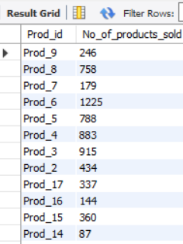

**Q11.** select prod_id, product_sub_category from superstores.prod_dimen

where Product_Category in ('Technology', 'furniture');

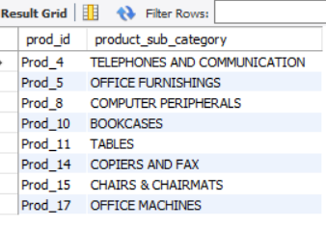

**Q12.** Select prod_dimen.Product_category, market_fact.Profit From superstores.market_fact

natural join prod_dimen group by Product_Category order by Product_Category desc;

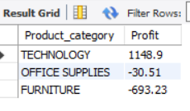

**Q13.** Select prod_dimen.Product_category, market_fact.Profit, prod_dimen.Product_Sub_Category From superstores.market_fact

natural join prod_dimen group by Product_sub_Category, Product_Category;

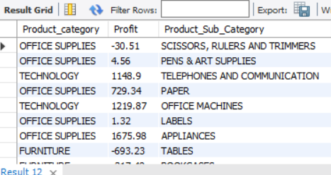

**Q14.** select orders_dimen.Order_date, market_fact.Order_Quantity, market_fact.Sales from superstores.orders_dimen natural join market_fact;

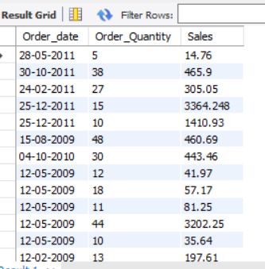

**Q15.i)** select customer_name from superstores.cust_dimen

where customer_name like '_r%';

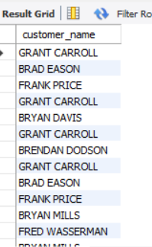

**Q15.ii)** select customer_name from superstores.cust_dimen

where customer_name like '___d%';

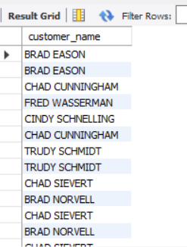

**Q16.** Select cust_dimen.Cust_id, market_fact.Sales, cust_dimen.Region, cust_dimen.Customer_name from superstores.cust_dimen

Natural join superstores.market_fact

where superstores.market_fact.Sales between 1000 and 5000

group by superstores.market_fact.Cust_id;

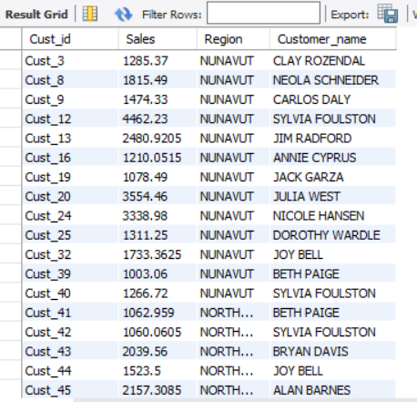

**Q17.** select sales from superstores.market_fact

order by sales desc limit 1 offset 2;

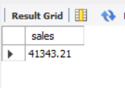

**Q18.**